 Introduction to Robotics

Group 13

Week 08 Date 27/03/15

Fergal Lonergan, Ruairí O’Donoghue, Kevin O’Flannagáin

**Assignment:** 4 [Search and rescue](https://csimoodle.ucd.ie/moodle/mod/resource/view.php?id=27306)

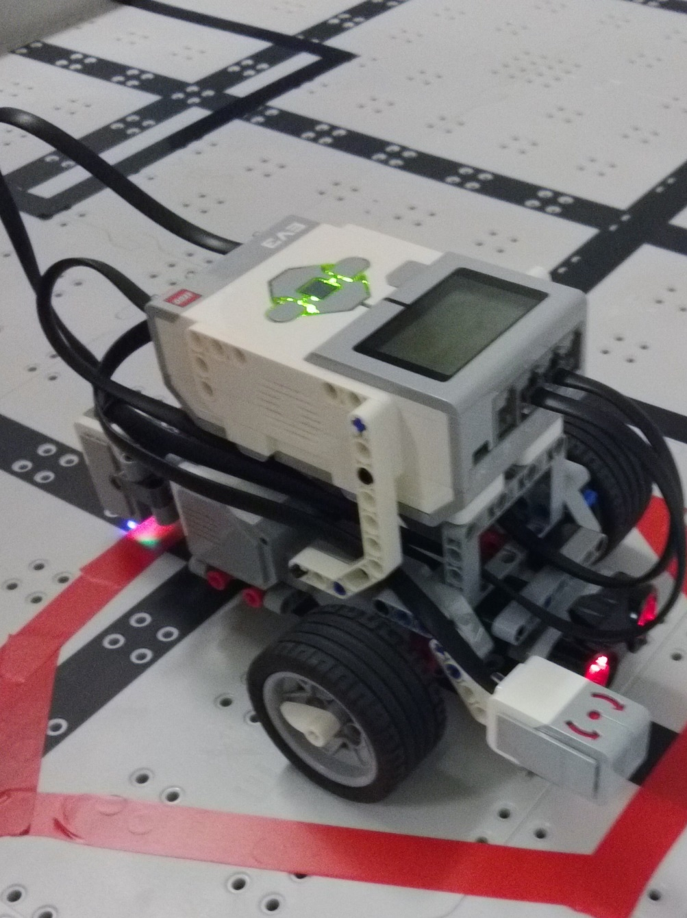Robot used for assignment.

**Goal:** For this week’s assignment we had to imitate a [Search and rescue](https://csimoodle.ucd.ie/moodle/mod/resource/view.php?id=27306) mission in order to in which you had to enter four “rooms” which would be randomly changed for each run. For this we were advised to write four separate programs, 1 for each room, and then to use different cases to navigate the mission. In order to do this we divided the work up. Each person took a room before entering the lab, in order to speed up the process, then we wrote the final room and combined each programme into one in the lab.

**Robot design:**

**Programs:**

**Learned:** In this challenge we learned that it is important to collaborate between team members on a project. We noticed that each member had a slightly different coding style and that in order for our program to run successfully these would all have to match. We also learned that dividing the one large task into smaller tasks simplifies the problem and speeds up the coding process.

**Finished Code:**

**Work Distribution:** Each member took a room before the lab, Fergal (empty with beep), Kevin (fire), and Ruairí (black box). Kevin and Ruairí then completed the lab as Fergal had an orthodontic appointment and couldn’t make the scheduled lab time. As Fergal was not going to be present for the lab session he undertook with the Goal, Learned and Work Distribution aspects of the report whereas Ruairí wrote the sections on Programs and Finished code as well as commenting our code submission, and Kevin took the picture, video and completed the Robot Design section as well as collating the final submission of the report.